***PAAREES PERFUMES***

***DAVIDOFF***

***FOR UNISEX***

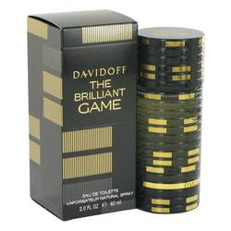

# *The Brilliant Game*

***Description:***

The Brilliant Game by Davidoff Cologne. Davidoff released The Brilliant Game in 2014. This fragrance for unisex is full of charm and charisma, and is also complex but fun. From its opening cocktail blend of Campari and vermouth to its sweet finish of orange blossom and tonka bean, this unique fragrance is perfect for unisex who want their scent to match their charming personalities. Wear this fragrance when you're out with friends or when you want to impress others without saying a word.